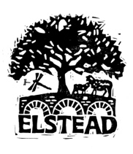

ELSTEAD PARISH COUNCIL

Website Policy

Adopted: September 2019
Reviewed and Approved: 19th May 2025

Website
Elstead Parish Council has created a new community website for the village. The website can be found at www.elsteadvillage.co.uk

The website will provide an easy-to-navigate environment whereby residents, visitors and potential newcomers will be able to see what’s on, what to visit and which clubs exist. It will list walks, helpful local information and historical facts about the village. Within the website there will be a section dedicated to Parish Council information.

Some businesses such as restaurants cafes and b&b’s and have been listed as these are deemed as services. The website will not be a directory of all local trade businesses however this may change in time.

The website will be updated regularly and is reliant on information provided by local clubs, societies and any individuals who might like to contribute.

The Parish Council will fund the running costs of website. The administration of the site and initial design has been provided for free.

As with the village facebook (which is not connected to the Parish Council), the Administrators have the right to veto any copy deemed unsuitable.

Any articles or information posted by the Council must reflect and be in line with the Parish Council’s code of conduct.

Document Owner
The Clerk

Signed and Dated

___________________________________ Cllr Jane Jacobs (Chair)

